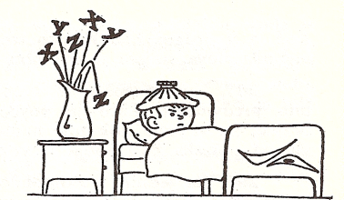
Linearne jednadžbe
( domaći rad)

- –x-5=-4

- 0.7+x=-1.83

- x-1$\frac{2}{3}$=3$\frac{1}{2}$

- 1$\frac{4}{5}x=−7\frac{1}{5}$

- 3(x-2)=-4(x-1)

- (2x-3):4=(3x-4):5

- -5(6x-3)=14(5x-2)+5(3-4x)

- 2x-2·{3x+[5x-(2x-3)]}=4x-2(x+15)-3

- $\frac{2x}{5}−\frac{3x}{4}$=0.3

- $\frac{x+\text{13}}{4}$=5-$\frac{\text{11}−2x}{5}$

- $$\frac{1}{3}(x+\text{10})−3=−\left[\frac{1}{4}(x−3)+\frac{1}{6}(5x+1)\right]$$

